Project Design Phase-II
Technology Stack (Architecture & Stack)
Date | 12 February 2026
Team ID | LTVIP2026TMIDS89609
Project Name | Online Payments Fraud Detection using  Machine Learning
Maximum Marks | 4 Marks

Technical Architecture
S.No | Component | Description | Technology
1 | User Interface | Transaction input, monitoring dashboard, fraud result display | HTML, CSS,  JavaScript / React  (Optional)
2 | Application Logic | API endpoints, transaction routing, | Python (Flask / FastAPI)
Architecture includes Web UI / Payment Interface, Backend API layer, preprocessing pipeline, Machine Learning fraud detection model, transaction database, and optional integration with payment gateway APIs. Initial deployment can be Local with a cloud-ready scalable design.
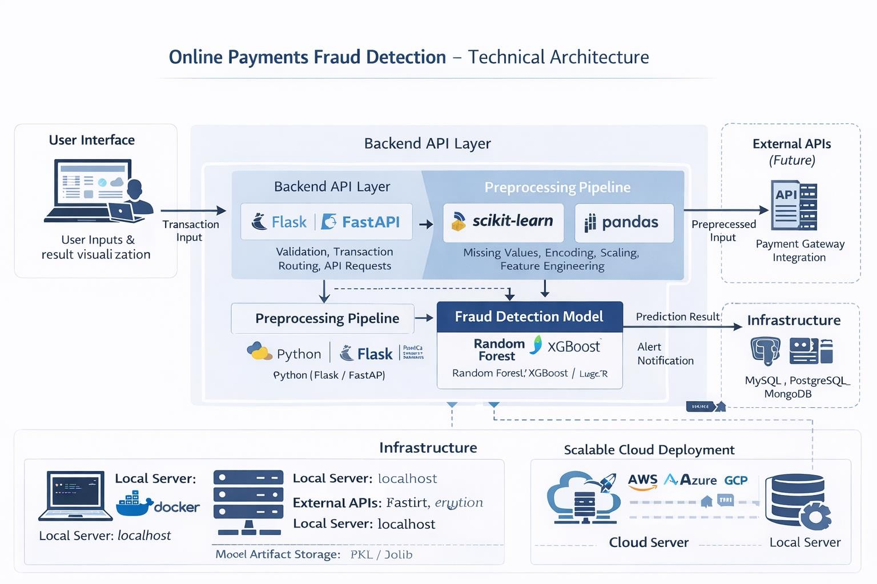

Table-1: Components & Technologies
 |  | validation
3 | Preprocessing Pipeline | Missing value handling, encoding, scaling, feature engineering | scikit-learn, pandas,  NumPy
4 | Machine Learning Model | Fraud detection & probability scoring | Random Forest /  XGBoost / Logistic Regression
5 | Database / Storage | Transaction records, logs, model artifacts | MySQL /  PostgreSQL /  MongoDB
6 | Model Artifact Storage | Store trained model files (PKL/Joblib) | Local File System
7 | External API (Future) | Payment gateway integration | Stripe API /  Razorpay API  (Optional)
8 | Infrastructure | Local deployment;  scalable cloud deployment | Localhost, Docker  (Future), AWS /  Azure / GCP

Table-2: Application Characteristics
S.No | Characteristics | Description | Technology
1 | Open-Source Frameworks | ML and backend built using opensource stack | Flask/FastAPI, scikit-learn, pandas
2 | Security  Implementations | Secure transaction handling, encryption, input validation | HTTPS, JWT/Auth, Data Encryption
3 | Scalable  Architecture | Modular layered design; cloud-ready | 3-tier architecture,  Docker/Kubernetes (Future)
4 | Availability | Continuous fraud monitoring support | Cloud VM, Load Balancer (Future)
5 | Performance | Real-time lowlatency fraud detection | Optimized inference pipeline, caching (Future)

